CC-215-L: Database Systems Lab
BS(IT) - Fall 2024
LAB – 011

The objective of this lab is to:
- PL/SQL BASICS
- LOOP
- CURSORS
- PREVIOUS CONTENT

Course & Lab Instructor: Dr. Asif Sohail
LAB TIMING : 90 MINS
TOTAL MARKS : 50
- Kindly paste the query as well as result table screenshot as a result of each task
Task 01: [25 marks]
- [3] Write a PL/SQL block that takes two numbers as input and display the larger number.
- [3] Write a PL/SQL block that takes job as an input, and display number of employees and the average salary of the given job.
- [3] Write a PL/SQL block that takes sal an input, and finds the number of employees above, below, and equal to the given sal.
- [4] Write a PL/SQL block to print the following pattern on the screen. Ask the number of rows from the user


- [4] Write a program that receives an employee name. Calculate their Total Annual Income plus their commission and display it. If the commission is NULL in the Table, the program must treat it as 0 to avoid calculation errors. It must also handle the no data found and too many rows exceptions.

- [4] Write a program that accepts an employee's id and finds the name of their Manager. If the employee has no manager then display:
Employee with {empno} has no manager.
(Make sure to handle Exception)
- [4] Write PL/SQL Block which takes department number as input and then uses a parametrized cursor to display the department name and the employees working in that department.
Task 02: [15 marks]
- Write a PL/SQL block that categorizes employees based on their hire date.
- If they were hired before 1982, label them 'Veteran'.
- If hired between 1982 and 1985, label them 'Senior'.
- Otherwise, label them 'Junior'. Display the Name, Hire Date, and their new Label
(Use Cursor)
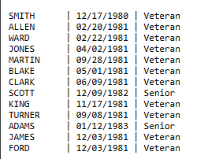
CLOSE c_tenure;
END;
- Write a PL/SQL block CALC_TAX that takes an employee number from the user. It should display the tax amount based on their salary:
- Sal > 3000: Tax is 15%
- Sal 1500 - 3000: Tax is 10%
- Sal < 1500: Tax is 0%
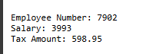
- Create a PL/SQL Block DEPT_STATS that displays a summary for every department. The output should list the Department Name, the Count of employees in that department, and the Total Salary payout for that department.
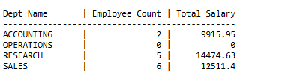
. VIVA VOICE (5)

